Build Your Own Story!

In this interactive workshop, the children and I will explore the basic building blocks of story. We will examine:
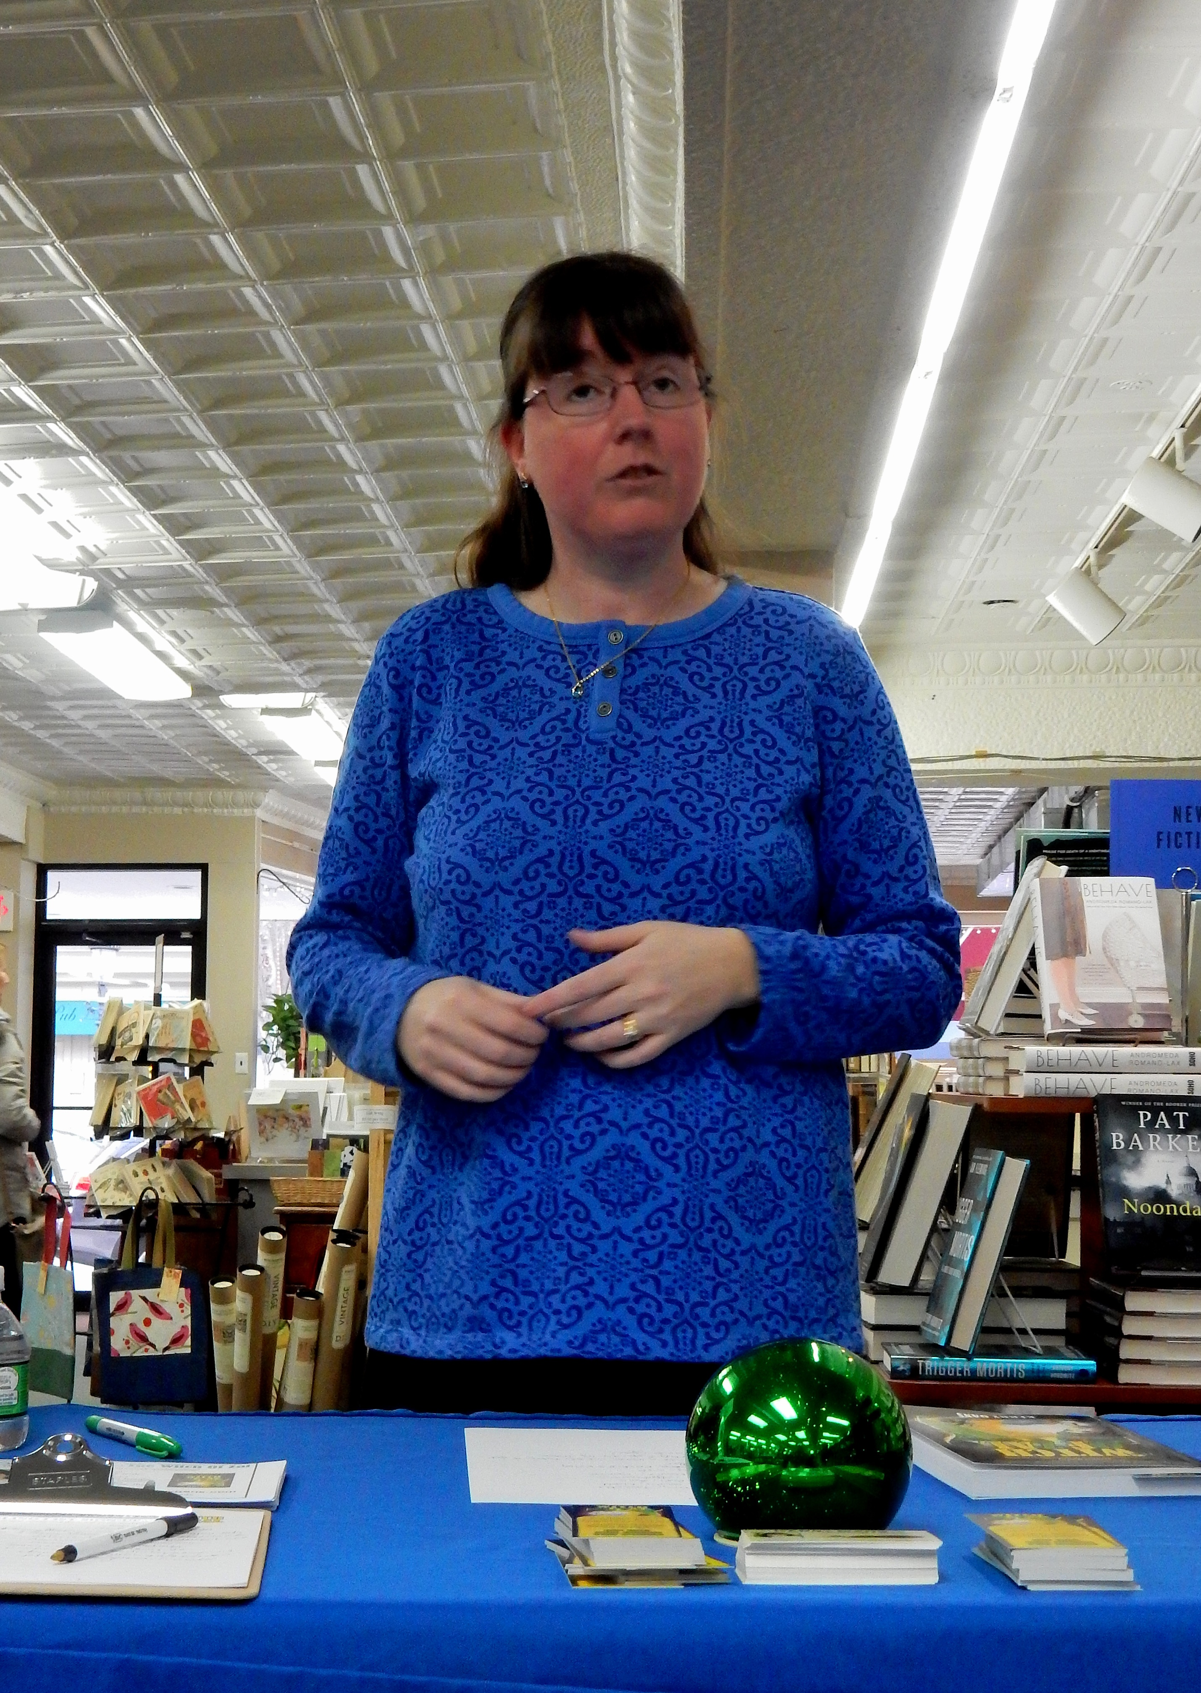
Character (Who)
Setting (Where/When)
Goal (What)
Conflict (Why)
Plot (How)

With younger children (K-3rd) I focus on the first 3 points, and go more in-depth with the older children (4th and up).

Once we have discussed the elements needed to tell a story, we will brainstorm a story together. With younger children we will brainstorm as a group, while older children will have time to brainstorm their stories on their own or in collaboration with others. The older children will have the opportunity to share their ideas before the workshop ends.

Every child has a story to tell. Let their inner hero shine.

Take-home materials will include a list and definitions of the elements of story, as well as my contact information in case any of the children (or teachers!) want to share their story ideas with me or ask me questions.

*****
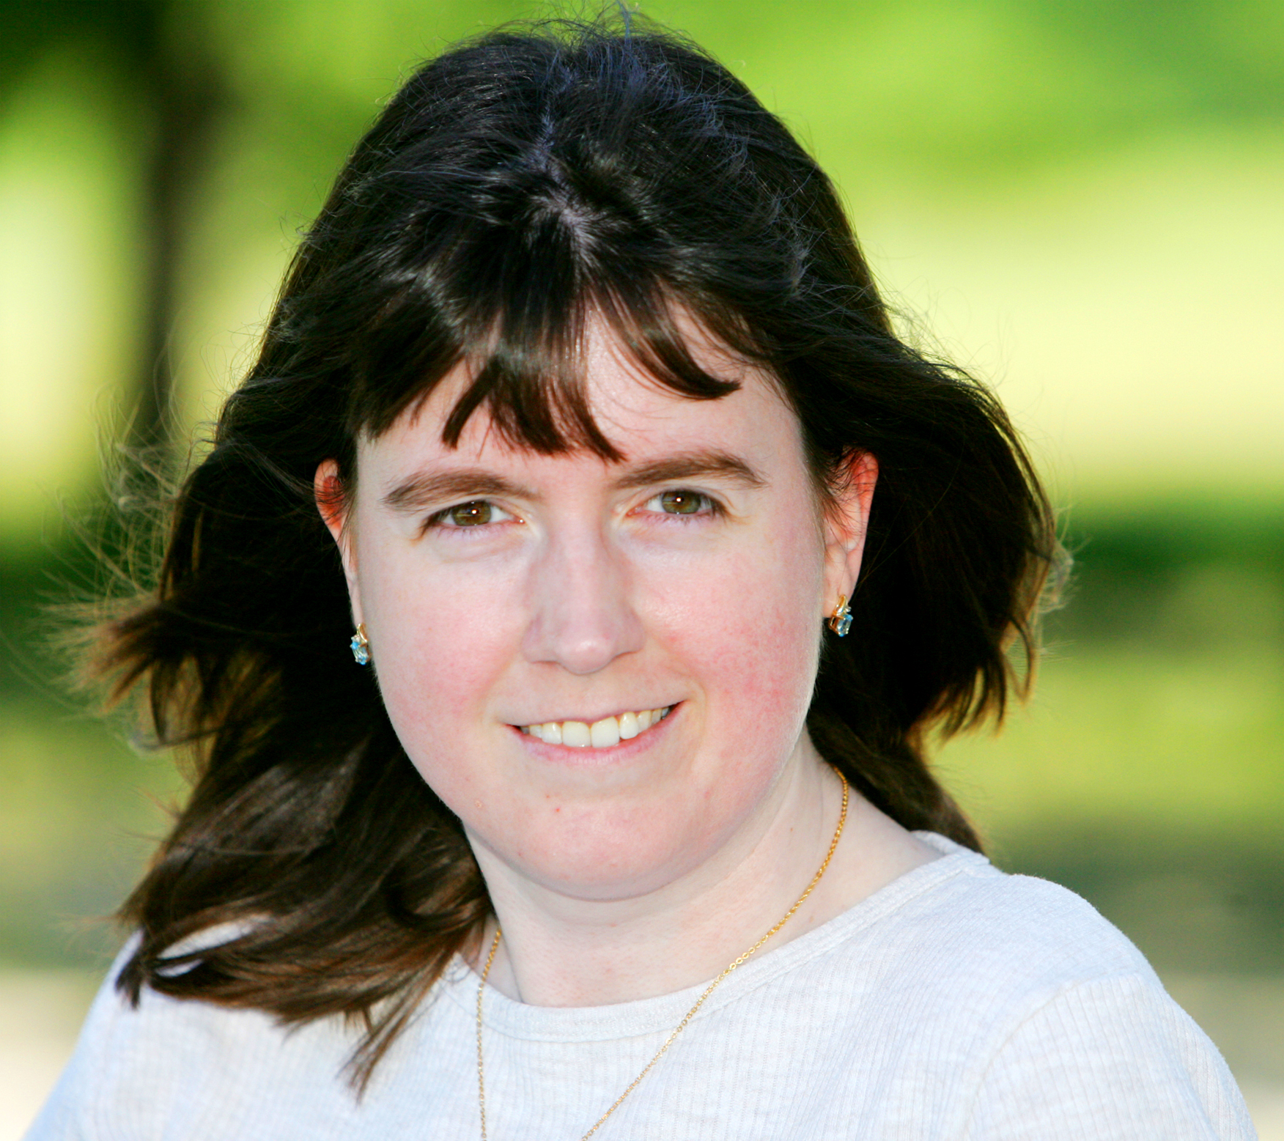
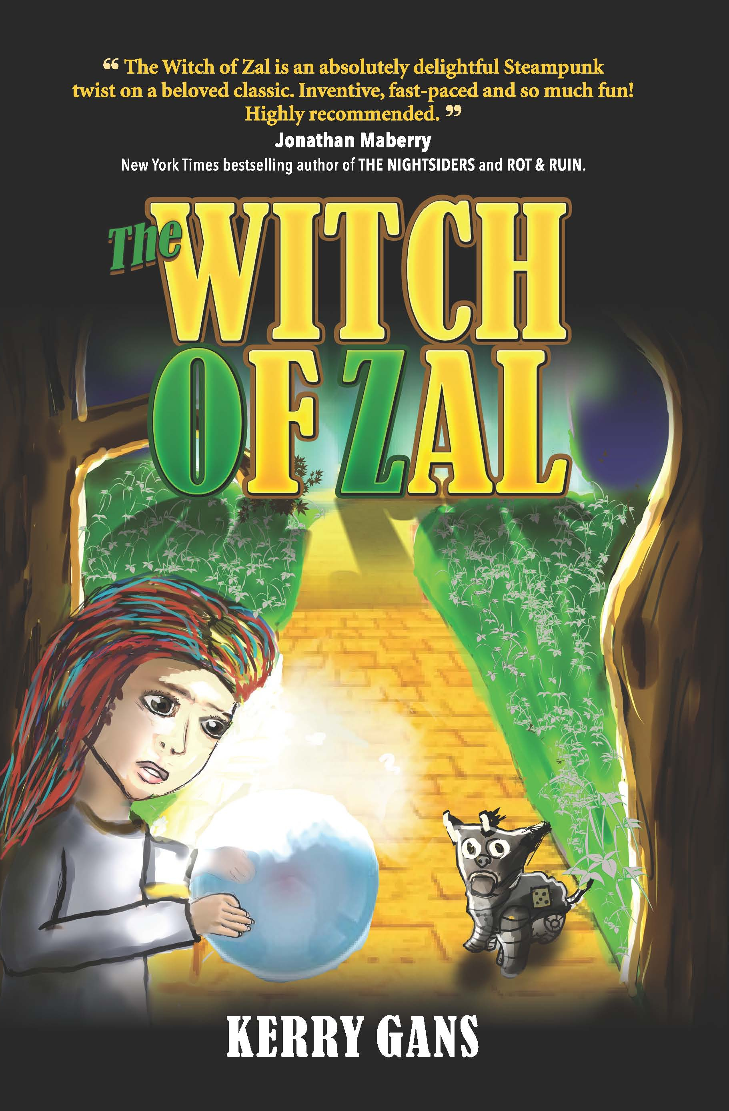
Kerry Gans is the author of several short stories, a family history book, and the middle grade novel THE WITCH OF ZAL. She is a chocoholic theater geek, believes libraries are magic, and considers Chincoteague Island her perfect writing retreat. When not writing, she haunts cemeteries and dusty archives in search of long-dead ancestors and pursues her most important work-in-progress, her daughter.

For more info or to contact Kerry, check out her website, group blog (The Author Chronicles), Facebook, Twitter, Google+, Pinterest, or Goodreads.

